NPTEL WORKSHOP – ANALOG LAB
Wadhwani Electronics Laboratory
Electrical Engineering Department, IIT Bombay

DAY 4 LAB REPORT
MOS Characterization and Amplifier Design

Name: Sahil Ingale
1. Square root amplifier:
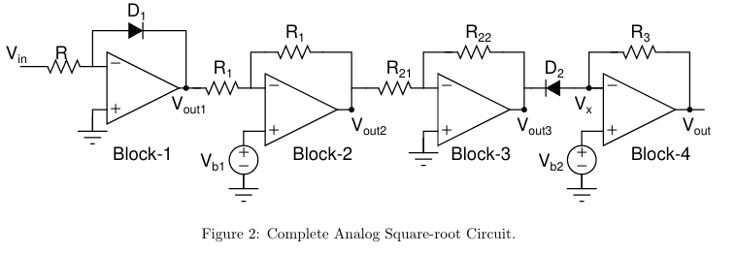
Figure 1:Output of square root amp.
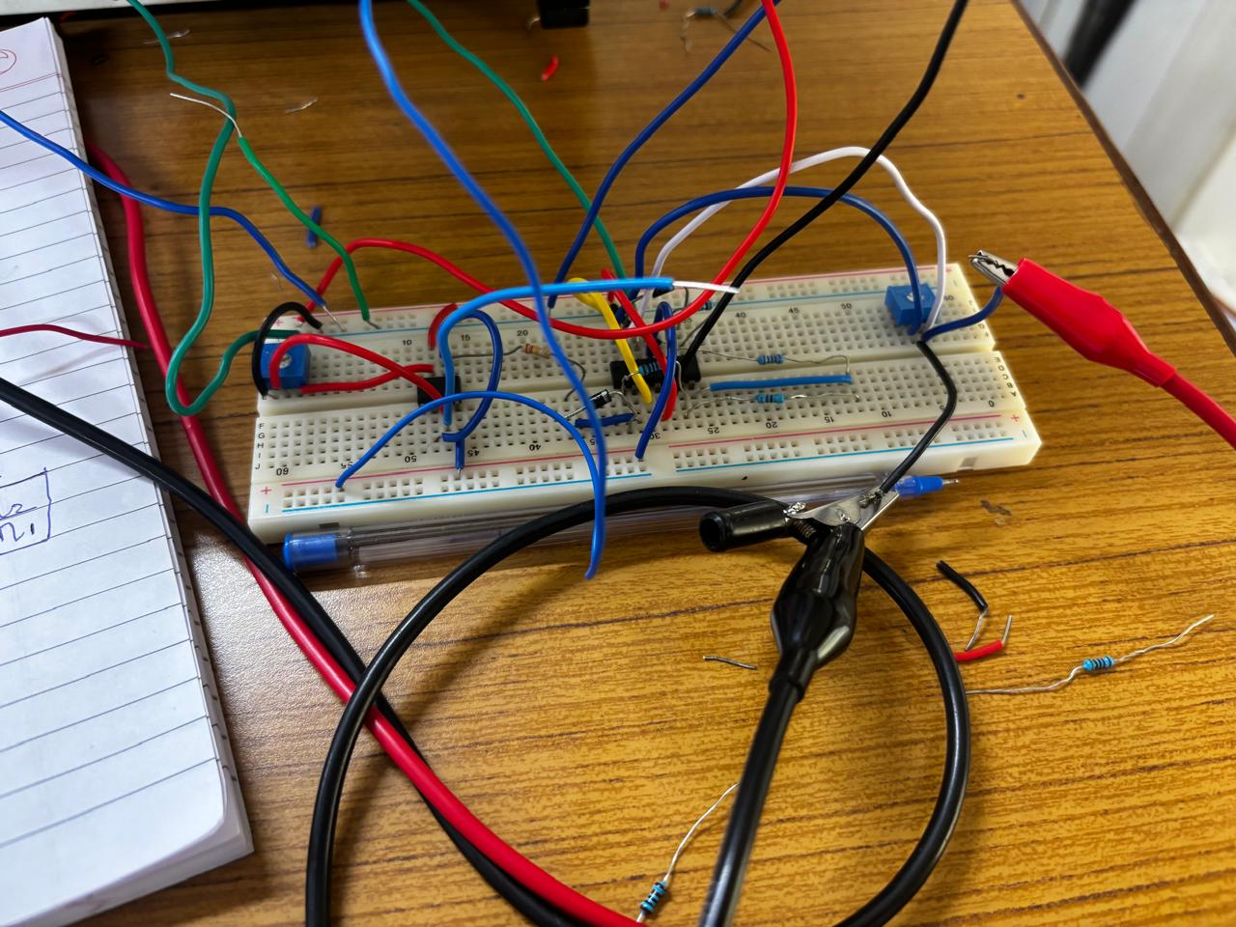

Input=1V:
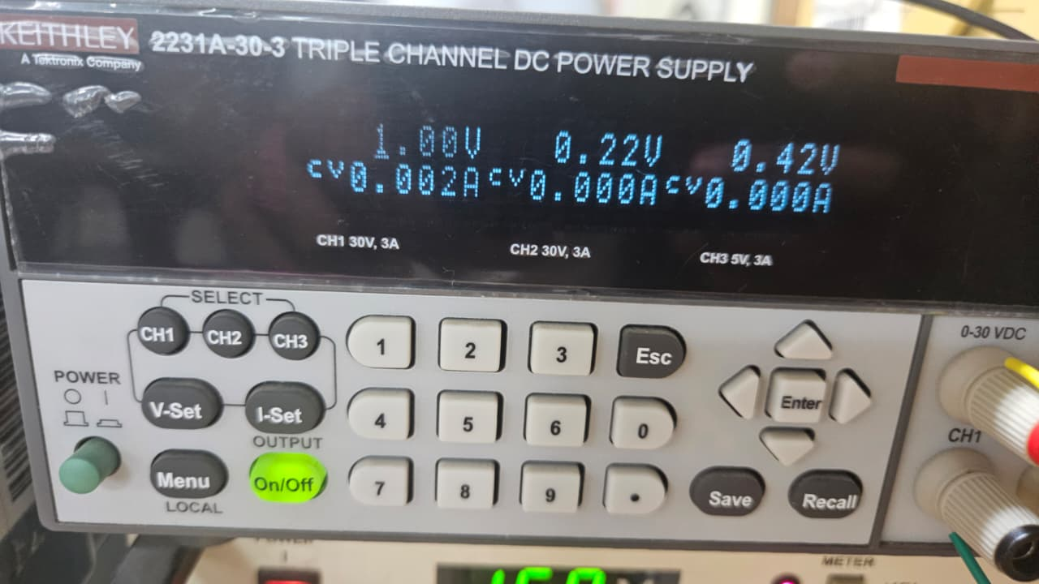

Stage 1:
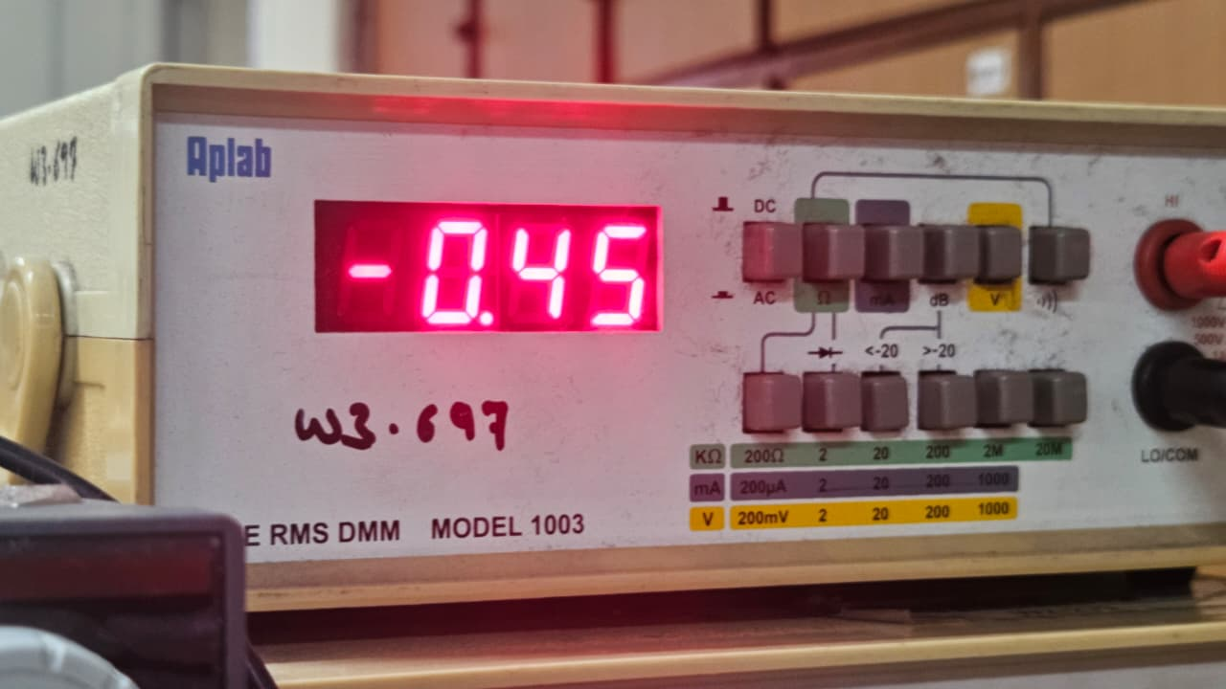

Stage 2:
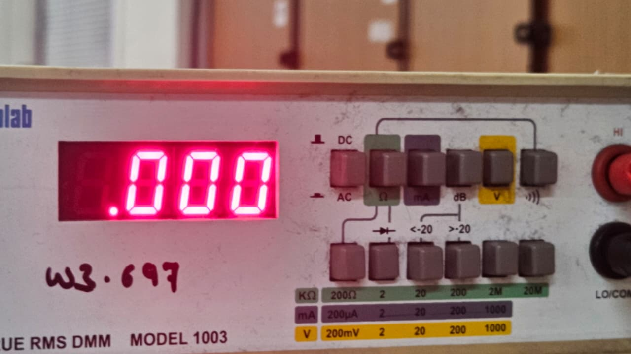
Stage 3:
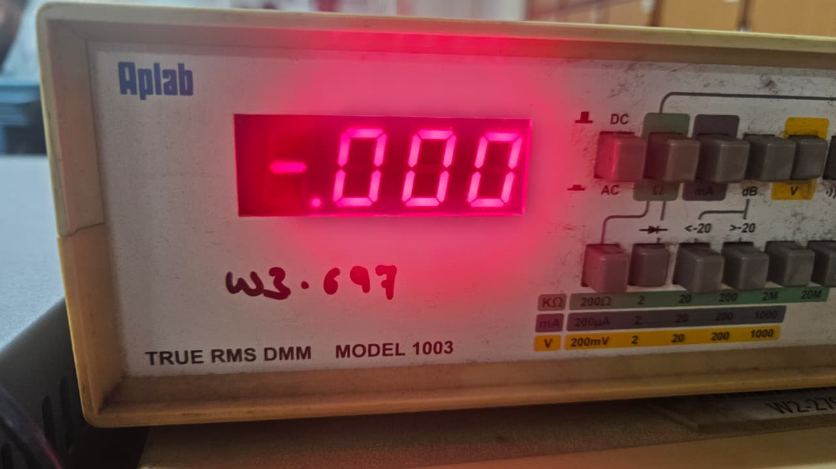
Final Output:
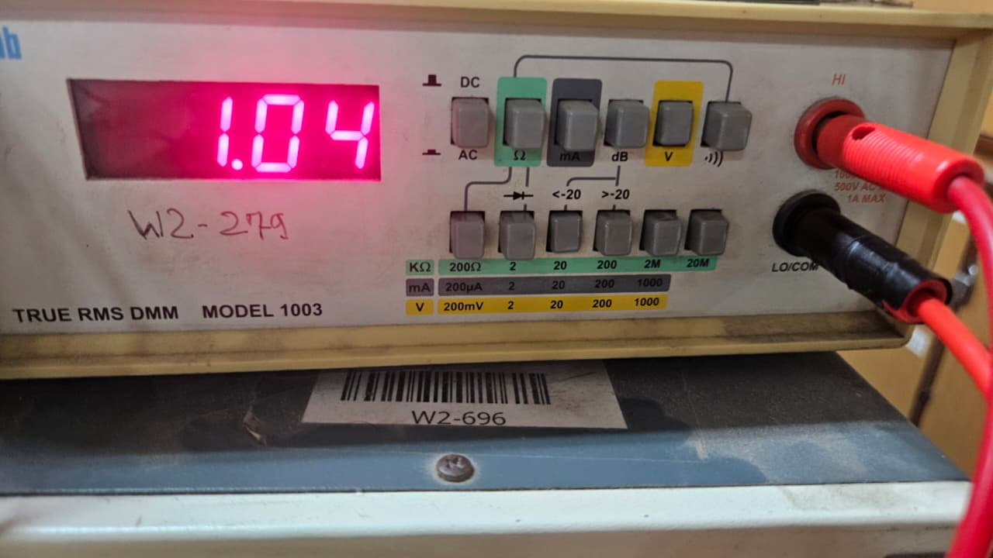

Input=2V:
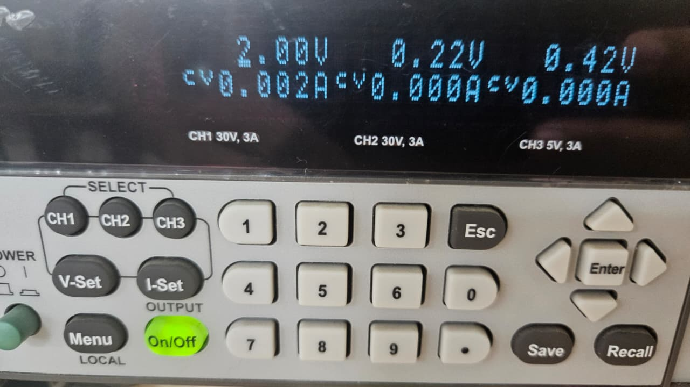

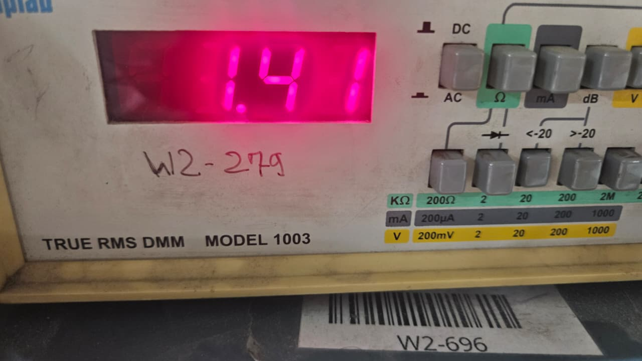

Input=3V:
